AP Chem Unit 4 – Equilibrium Notes Outline

Reaction Equilibrium:

Example: A + B ⇌ C + D
Time
Rates

Once EQ is established

Example: 2NO_{2 (g)} ⇌ N₂O_{4 (g)}

Graph Pressure vs Time if the initial pressure of NO₂ is 3.0 atm and the pressure of NO₂ at equilibrium is 1.0 atm. Create intervals on the graph provided.
Time
Pressure

Law of Chemical Equilibrium

Equilibrium Expression:

aA + bB ⇌ cC + dD K_{c} = K_{P} =

Range of K
If K << 1
If K >> 1
If K = 1
If K > 1.0x10⁷

K Expressions:

Example: Write the equilibrium expression for the following reaction.
PbI_{2 (s)} ⇌ Pb²⁺_{(aq)} + 2I⁻_{(aq)}

Wrong:

Correct:

Example: Write the K_{c} and K_{p} for the following reaction.
2NH_{3 (g)} ⇌ N_{2 (g)} + 3H₂ _{(g)}

Solving for K and Concentrations using ICE Table

Example: COCl_{2 (g)} ⇌ CO_{(g)} + Cl_{2 (g)}

3.0 mol of COCl₂ are added to a 1.5 liter container at 650 K. The reaction reaches equilibrium and the [COCl₂] = 0.25 M. Calculate K_{c} for this reaction at 650 K. Describe the equilibrium as reactant favored, product favored, or neither.

COCl_{2 (g)} ⇌ CO_{(g)} + Cl_{2 (g)}
Initial
Change
Equilibrium

Example: 2NH_{3 (g)} ⇌ N₂ _{(g)} + 3H_{2 (g)}

3.0 mol of NH₃ are placed in a 1.5 liter container. The reaction establishes equilibrium and the [NH₃] = 0.5 M. Describe the

Initial
Change
Equilibrium

Applying Equilibrium to Dalton’s Partial Pressures

Example: 2H₂ _{(g)} + O_{2 (g)} ⇌ 2H₂O _{(g)}

H₂ and O₂ are added into a container and the initial pressures are recorded.

P_{H2} = 1.3 atm
P_{O2} = 1.1 atm

The reaction is allowed to reach equilibrium and the total pressure after equilibrium is measured to be 2.3 atm

Goal: Calculate K_{p} for this reaction.

Example: PCl₅ _{(g)} ⇌ PCl_{3 (g)} + Cl_{2 (g)}

The initial pressure for PCl₅ is 1.66 atm. The reaction is allowed to reach equilibrium and the final pressure is measured to be 2.35 atm. Calculate the K_{p} for this reaction.

Example: Br₂ _{(g)} + I_{2 (g)} ⇌ 2IBr_{(g)} K_{p} = 70

If 0.25 atm of Br₂ is combined with 0.25 atm of I₂, what is the P_{IBr} once equilibrium is established? Calculate the total pressure as well.

When to Negate -x

Example: H₂CO₃ _{(aq)} ⇌ H⁺_{(aq)} + HCO₃⁻_{(aq)} K_{c} = 4.3x10⁻⁷

Determine the [HCO₃⁻] if the initial [H₂CO₃] = 1.20 M.

Example: N_{2 (g)} + O_{2 (g)} ⇌ 2NO_{(g)} K_{c} = 4.2x10⁻⁸

If the initial concentration of N₂ was 0.085 M and O₂ was 0.038 M, what is the concentration of nitrogen monoxide at equilibrium?

Manipulating Reactions and Effects on K Values

Ways to manipulate a rxn
- Coefficients:

- Reversing a rxn:

Example: 2A + B ⇌ 3C K_{c} = 2.5x10⁻³

How would the following affect the K_{c}?

- 4A + 2B ⇌ 6C K_{c} =

- A + ½ B ⇌ 3/2C K_{c} =

- 3C ⇌ 2A + B K_{c} =

Example: Calculate K_{c} for the rxn: 2N₂O + 3O₂ ⇌ 2N₂O₄ K_{c} = ?

Given Reactions

Rxn 1: 2N₂ + O₂ ⇌ 2N₂O K_{c} = 1.2x10⁻³⁵

Rxn 2: N₂O₄ ⇌ 2NO₂ K_{c} = 4.6x10⁻³

Rxn 3: ½ N₂ + O₂ ⇌ NO₂ K_{c} = 4.1x10⁻⁹

Goal: Manipulate the above equations to get to the overall equation. This will allow you to solve for the K_{c} of the overall equation.

Using the Reaction Quotient(Q)

Reaction Quotient:

Q vs K_{c}/K_{p}:

Example: N_{2 (g)} + 3H_{2 (g)} ⇌ 2NH_{3 (g)} K_{p} = 1.64x10⁻⁴

A closed vessel contains each gas at the following pressures: 1.5 atm of N₂, 3.2 atm of H₂, and 0.75 atm of NH₃.

- How do we check if the reaction is at equilibrium?

- Perform the calculations necessary to determine if the reaction is at equilibrium. If not, determine how the reaction will shift to reestablish equilibrium.

Example: SO₂Cl₂ _{(g)} ⇌ SO₂ _{(g)} + Cl_{2 (g)} K_{c} = 0.078 @ 100ºC

0.035 moles of SO₂, 0.500 moles of SO₂Cl₂, and 0.080 moles of Cl₂ are combined in a sealed 5.00 L flask and heated to 100ºC. Is the reaction at equilibrium when 100ºC is reached? If not, determine how the reaction will shift to reestablish equilibrium.

Example: At 445ºC, K_{c} for the following reaction is 0.020.

2HI(g) ⇌ H₂(g) + I₂(g)

A mixture of H₂, I₂, and HI in a vessel at 445ºC has the following concentrations: [HI] = 2.0 M, [H₂] = 0.50 M and [I₂] = 0.10 M. Which one of the following statements concerning the reaction quotient, Q_{c}, is TRUE for the above system?

(a) Q_{c} = K_{c}; the system is at equilibrium.
(b) Q_{c} is less than K_{c}; more H₂ and I₂ will be produced.
(c) Q_{c} is less than K_{c}; more HI will be produced.
(d) Q_{c} is greater than K_{c}; more H₂ and I₂ will be produced.
(e) Q_{c} is greater than K_{c}; more HI will be produced.

Le Chatlier’s Principle

Le Chatlier’s Principle:

Stressing a Chemical Reaction @ EQ (4 Stressors to Rxns)

- Concentration/Pressure Stress:

Example: N_{2 (g)} + 3H_{2 (g)} ⇌ 2NH_{3 (g)}

The reaction is at equilibrium indicated by the concentrations of each gas being constant. Show how the concentrations would change if a small amount of N₂ is injected, and the reaction is allowed to reestablish equilibrium.

Use the reaction quotient, Q, to explain the changes in concentration when EQ is reestablished.
Time
Concentration
[NH₃]

[H₂]

[N₂]

Example: N₂O_{4 (g)} ⇌ 2NO_{2 (g)}
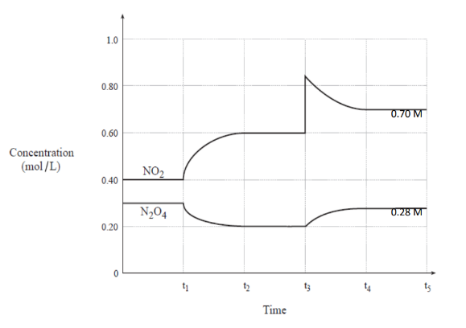
- At t₁ the gases are combined in the same container. At what time is equilibrium established in the reaction between the two gases?

- Write the equilibrium expression, K_{c}, for the reaction above.

- A stressor is placed on the reaction. Indicate at what time this occurs and describe what the stressor is.

- Use the reaction quotient, Q, to describe the change and how the reaction will reestablish equilibrium.

- On the graph to the below, show how the concentrations would change if you were to add more N₂O₄ instead of NO₂. Use reaction quotient, Q, to explain the changes in concentration.
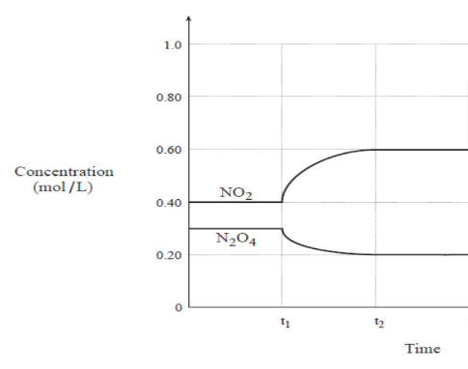

- Temperature Stress

What is affected by temperature:

Exothermic Reaction: A + B ⇌ C + Heat K_{c} = 200 @ 25ºC

The reaction temperature is increased to 30ºC.

Reaction Shift:

The reaction temperature is lowered to 20ºC.

Reaction Shift:

Endothermic Reaction: Heat + A + B ⇌ C K_{c} = 200 @ 25ºC

The reaction temperature is increased to 30ºC.

Reaction Shift:

The reaction temperature is lowered to 20ºC.

Reaction Shift:

Example: N₂ + 3H₂ ⇌ 2NH₃ ∆H = 25.0 kJ/mol

- Where is heat in the reaction? Think about the enthalpy value!

- The system above is @ EQ. The temperature is lowered. How will the reaction shift? Use the reaction quotient, Q, to explain the change in EQ.

- Volume Stress on Gases (Change container size)

Example: N_{2 (g)} + 3H_{2 (g)} ⇌ 2NH_{3 (g)}

The above reaction is currently at equilibrium in a 3.0 L container. The gases are then transferred into a 1.5 L container. Determine the effect this will have on the equilibrium. Use the reaction quotient, Q, to help you explain the shift, if any.

Fast way to determine shift:

4) Volume Stress on Solutions (Change amount of Solvent)

Example: HCH₃COO_{(aq)} ⇌ H⁺_{(aq)} + CH₃COO⁻_{(aq)} K_{c} = 3.8x10⁻⁵

- Write the K_{c} expression for the dissolution equation above.

- A solution of 1.0 M acetic acid has 2.0 L of H₂O added. Do the number of moles of CH₃COO⁻ increase, decrease, or remain the same? Use reaction quotient, Q, to help you explain.

Fast way to determine shift:

Non-Stressors in Equilibrium

- Catalyst:

- Surface Area of Reactant:

- Addition of non-reactive (g):


You have made it to the end of the equilibrium notes! Congratulations. Here is a cookie.

